ГУАП

КАФЕДРА № 43

ОТЧЕТ   
ЗАЩИЩЕН С ОЦЕНКОЙ

ПРЕПОДАВАТЕЛЬ

|  |  |  |  |  |
| --- | --- | --- | --- | --- |
| старший преподаватель |  |  |  | Н.А.Соловьева |
| должность, уч. степень, звание |  | подпись, дата |  | инициалы, фамилия |

|  |
| --- |
| ОТЧЕТ О ЛАБОРАТОРНОЙ РАБОТЕ №4 |
| ОСНОВНЫЕ ОБЪЕКТЫ ПРОВАЙДЕРА ДАННЫХ: ОБЪЕКТ COMMAND |
| по курсу: КОНСТРУИРОВАНИЕ ИНФОРМАЦИОННЫХ СИСТЕМ |
|  |
|  |

РАБОТУ ВЫПОЛНИЛ

|  |  |  |  |  |  |
| --- | --- | --- | --- | --- | --- |
| СТУДЕНТ ГР. № | 4631 |  |  |  | А.А.Воронин |
|  |  |  | подпись, дата |  | инициалы, фамилия |

Санкт-Петербург 2018

**1. Названия использованных элементов**

* Имя SQL – сервера: DESKTOP-II3EQ3T
* Имя БД – Кадры
* Имя таблицы – Department
* Столбцы:

1. Идентификатор отдела
2. Количество работников
3. Название отдела
4. Адрес
5. Почта
6. Телефон

**2. Скриншот экрана с формой**

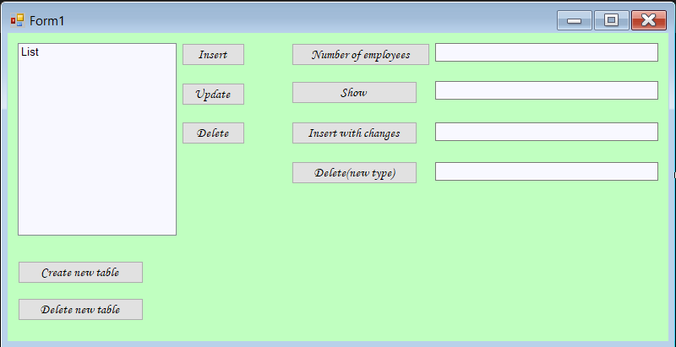

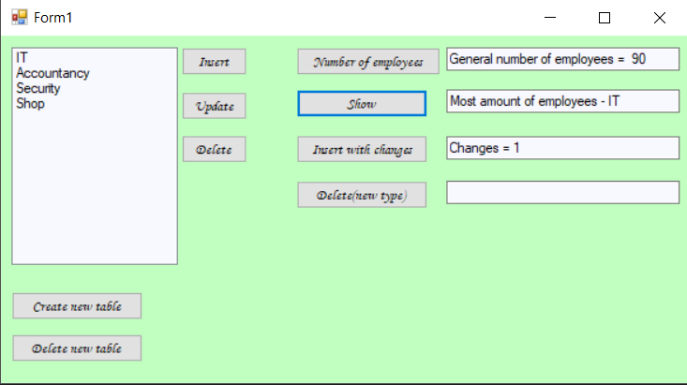

**3. Код программы**

using System;

using System.Collections.Generic;

using System.ComponentModel;

using System.Data;

using System.Drawing;

using System.Linq;

using System.Text;

using System.Windows.Forms;

using System.Data.SqlClient;

namespace vol._1._0

{

public partial class Form1 : Form

{

public Form1()

{

InitializeComponent();

}

SqlConnection cnn = new SqlConnection(@"Data Source=DESKTOP-II3EQ3T;Initial Catalog= Кадры; Integrated Security = True");

private void Form1_Load(object sender, EventArgs e)

{

}

SqlCommand cmd = new SqlCommand();

private void button1_Click(object sender, EventArgs e)

{

cnn.Open();

cmd.Connection = cnn;

cmd.CommandText = "select sum([Population]) from Department";

textBox1.Text = "General number of employees = " + Convert.ToString(cmd.ExecuteScalar());

cnn.Close();

}

private void button2_Click(object sender, EventArgs e)

{

cnn.Open();

cmd.CommandText = "select NameDepartment from Department";

cmd.Connection = cnn;

SqlDataReader reader = cmd.ExecuteReader();

while (reader.Read())

{

List.Items.Add(reader[0].ToString());

}

cnn.Close();

cnn.Open();

cmd.Connection = cnn;

cmd.CommandText = "select NameDepartment from Department order by Population DESC";

textBox2.Text = "Most amount of employees - " + Convert.ToString(cmd.ExecuteScalar());

cnn.Close();

}

private void button3_Click(object sender, EventArgs e)

{

cnn.Open();

cmd.Connection = cnn;

cmd.CommandText = "insert into Department values (10,1,3,'Security','Nevsky23', 'sc@trump.com', '5160609')";

cmd.ExecuteScalar();

cnn.Close();

}

private void button4_Click(object sender, EventArgs e)

{

cnn.Open(); cmd.Connection = cnn;

cmd.CommandText = "update Department set Adress = 'Nevsky 153' where [Population] > 10";

cmd.ExecuteScalar();

cnn.Close();

}

private void button5_Click(object sender, EventArgs e)

{

cnn.Open();

cmd.Connection = cnn;

cmd.CommandText = "delete from Department where [Population] < 10";

cmd.ExecuteScalar();

cnn.Close();

}

private void label1_Click(object sender, EventArgs e)

{

}

private void button6_Click(object sender, EventArgs e)

{

cnn.Open();

cmd.Connection = cnn;

cmd.CommandText = "insert into Department values (3,1," + textBox3.Text + ",'Security','Nevsky 23','sc@trump.com', '5160609')";

textBox3.Text = "Changes = " + Convert.ToString(cmd.ExecuteNonQuery());

cnn.Close();

}

private void button7_Click(object sender, EventArgs e)

{

cnn.Open();

cmd.Connection = cnn;

cmd.CommandText = "delete from Department where Population = " + textBox4.Text;

textBox4.Text = "Deleted = " + Convert.ToString(cmd.ExecuteNonQuery());

cnn.Close();

}

private void button8_Click(object sender, EventArgs e)

{

cnn.Open();

cmd.Connection = cnn;

cmd.CommandText = "create table Day (DayName int primary key, Sales int) ";

cmd.ExecuteNonQuery();

cnn.Close();

}

private void button9_Click(object sender, EventArgs e)

{

cnn.Open();

cmd.Connection = cnn;

cmd.CommandText = "drop table Day";

cmd.ExecuteNonQuery();

cnn.Close();

}

private void textBox1_TextChanged(object sender, EventArgs e)

{

}

}

}